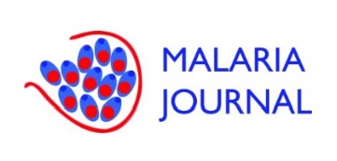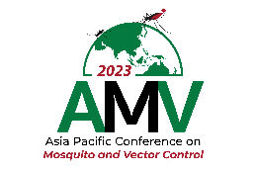

APPLICATION FORM FOR PRESENTATION AWARD

The Asia Pacific Conference on Mosquito and Vector Control (AMV) - 2023 Organizing Committee places significant emphasis on nurturing the next wave of young scientists specializing in vector-borne diseases. We are steadfast in our belief that these emerging researchers possess the capability to lead global initiatives aimed at alleviating the challenges posed by these diseases.

With the gracious support from the Malaria journal, we are privileged to offer awards for exceptional presentations at the meeting. These awards are geared towards recognizing and celebrating the innovative and rigorous research efforts of young scholars. We invite applications from students or young research scientists who are within 10 years post their Master’s or PhD graduation. The awards consist of a certificate, a cash prize valued at $250, and an open access fee waiver to publish with Malaria journal. Additionally, the will be interviewed and showcased in a blog post on the Malaria journal website.

Personal Information
1. Name
2. Email Address
3. Contact Number
4. Affiliation
5. Current Position
6. Graduation Year (Master’s or PhD)
7. Title of Presentation
8. Co-authors (if applicable)
9. Abstract of Presentation

Contribution to the field & Future plans
How does your research contribute to advancing our understanding or addressing challenges in vector-borne diseases? (150-200 words):
How do you envision your research impacting the field of vector-borne diseases in the future? (150-200 words):

Additional Information
I hereby declare my willingness to participate in an interview conducted by the Malaria journal, should I be selected as an award winner for the conference presentation. I understand that the purpose of this interview is to discuss and showcase the innovative and rigorous aspects of my research in the field of vector-borne diseases. I grant permission to the Malaria journal to use the content of the interview, including quotes, photographs, and related materials, for publication and promotional purposes. | Yes | No
I hereby certify that the information provided in this application is accurate and complete to the best of my knowledge. I understand that any false information may lead to disqualification from the award selection process. | Yes | No
Remark

Please ensure that the application form and curriculum vitae (CV) are submitted as separate files. Both files may be submitted online no later than 30 September 2023, 17:00 (GMT+7) (Thailand time) through infoamv2023@gmail.com.

